# *Programming II (420-B20-HR)*

# *Lab 12 – Sorting and Control Break Reports*

Date assigned: Wednesday, April 13, 2016

Date due: **Wednesday, April 13, 2016**

**Learning Objectives**

At the end of this lab, the student will be able to:

1. Sort an array using a bubble sort
2. Create a single level control-break report with group headers and group footers

**To Be Handed In:**

1. The ***username*_B20_L12_Project** folder should be zipped and uploaded to **Moodle**.

**To Start:**

1. Download and unzip the folder **B20_L12_Project** from **Moodle**. Rename it to ***username*_B20_L12_Project**.
2. Start **Eclipse**.
3. Open your **Labs** workspace in your **420-B20** folder.
4. Create a new **Java Project** called ***username*_B20_L12_Project**.

# The Bubble Sort

***Purpose:*** Learn to use the bubble sort to sort an array.

***To Do:***

## Run **InventoryReportsFrame** and select **Sorted Inventory Report** from the **Reports** menu. Notice that the output is not sorted. Close the frame.

## Modify the **Inventory** class to sort the list using a bubble sort:

### Add a private **boolean** instance variable called **sorted** to the **Inventory** class.

### An empty **sortByMedia()**method has been added to the **Inventory** class. Complete coding is using the following algorithm:

1. sorted = false

2. loopend = numProducts - 1

3. loop while loopend > 0 and not sorted

3.1 sorted = true

3.2 Loop for j = 0 to loopend

3.2.1 If the media type for product[j] > the media type for product[j+1]

3.2.1.1 call switchProducts(j, j+1)

3.2.1.2 sorted = false

end-if

end-for loop

3.3 subtract 1 from loopend

end-while loop

### Code the **switchProducts()** method of the **Inventory** class. It should switch **product[j]** with **product[k]**.

## In the **InventoryReport** class, call the **sortByMedia()** method at the beginning of the **displaySortedReport()**.

## Run **InventoryReportsFrame** and select **Sorted Inventory Report** again. Look at the game titles. Are they sorted? _No_______. We want the product titles to be sorted alphabetically within the media type. Add an else clause to the if clause in the **sortByMedia()** method to see if the media types are the same. If they are, compare the titles and switch them if they are not in order. Test your changes. Your final report should look like:

## 

# Control-Break Reports

***Purpose:*** Learn to create a single-level control break report with totals.

***To Do:***

## We want to print the total number of products for each media type. To do this, we group the products by media type and count the products in a media type group. We need to keep track of the previous control field and to accumulate the counts for a group. The **totalProducts** instance variable has already been added to the **InventoryReport** class. Add the following instance variables to the **InventoryReport** class:

**mediaCount** – an integer group total

**mediaName** – a String for the current media name

**previousProduct** – a Product object

## Code the **displayByMedia()** method in the **InventoryReport** class. Use the following algorithm to display the control break report:

1. Create a **Heading** object with the title " Movies and Games" on one line and "Inventory Report by Media Type" on the next line. The heading should be 88 characters long.
2. Display the heading in the **reportDisplay** JTextArea
3. Call the **displayColumnHeadings()** method
4. Call the **inventory** **sortByMedia()** method.
5. Create a **Product** object called **product**
6. Initialize **totalProducts** to 0
7. Call **startNewMediaGroup()** for thefirst product in **inventory**.
8. For each product in the inventory:

9.1set **product** to the current product

9.2 If the media type for the product is different than the media type for **previousProduct**

9.2.1 Call the **processMediaTotals()** method passing **previousProduct**

9.2.3 Call **startNewMediaGroup()** for **product**

end-if

9.3 Call the **displayMediaDetailLine()** method for **mediaName** and   
 **product**

9.4 Increment **mediaCount**

9.5 Set **mediaName** to “”

end-for

10. Call the **processMediaTotals()** method for the last control group passing the **previousProduct**.

11. Call the **displayTotals()** method

## Test your changes by running **InventoryReportsFrame** and selecting "Inventory by Media Type". You'll get at NullPointerException because you haven't coded the **startNewMediaGroup()** method.

## Code the **startNewMediaGroup()** method using the following algorithm:

1. Set **mediaCount** to zero.
2. **mediaName** = name of media for **product**
3. **previousProduct** = **product**

## Run it again. You still aren't displaying the media totals and the grand total is still 0.

## Code the **processMediaTotals()** method using the following algorithm:

1. Display the media total line followed by a blank line. The output should look like:

Number of *mediaName*s: 999

where *mediaName* is the name of the previous name of media and *999* is mediaCount

2. Add **mediaCount** to **totalProducts**

## Test your changes.

## Add an instance variable, **mediaRentals**, to count the number of products rented for each media type and an instance variable, **totalRentals**, for all rentals.

## Modify the **displayByMedia()** method to initialize the **totalRentals** count and to increment **mediaRental** for each product if the product is rented. (The **isProductRented()** method returns true if the product is currently rented and false otherwise.)

## Modify the **startNewMediaGroup()** method to initialize the **mediaRentals** count.

## In **processMediaTotals()**, display a line before the media totals to display the media totals and update **totalRentals**. The two media total lines for movies should now look like:

**Number of Movies currently rented: 4**

**Number of Movies: 21**

## In **displayTotals()**, add a line before the report total to display the total rentals. The report total lines should now look like:

Total number of rentals: 7

**Total number of products: 30**

The final version of the report should look like the screen shot on the next page.

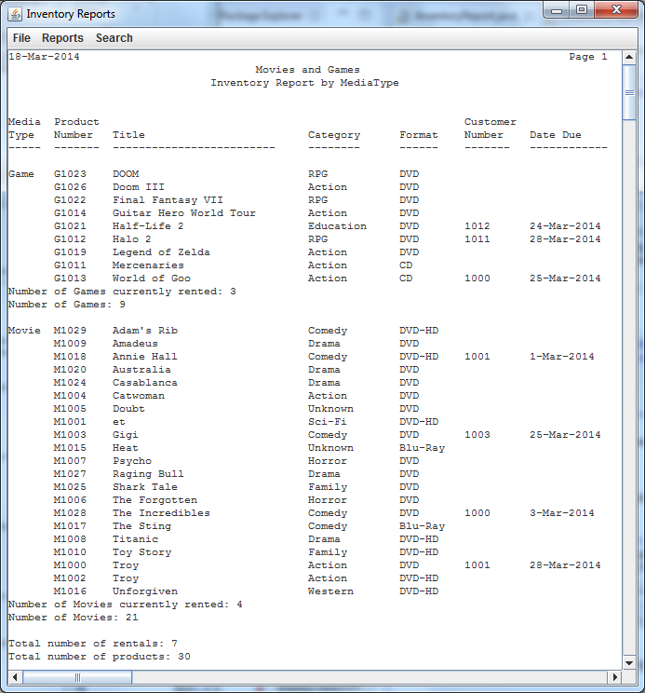

# Homework

## Complete the **Week 12 Quiz** on Moodle by April 17.